In a Microsoft Word document, complete and submit the following:
Evidence of access to Unix/Linux.

- Evidence of proper installation of Flex and Bison.
Susana:
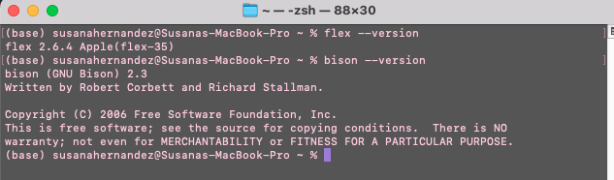
Soren Haynes:
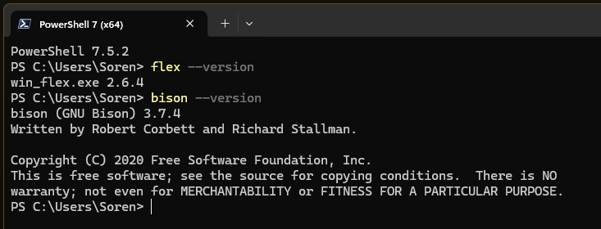
Justin Zhang:
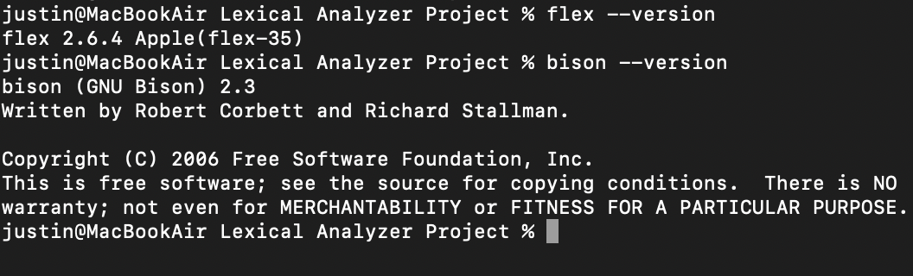
The screenshots above show the proper installation of Flex and Bison on Unix/Linux
Make sure all screenshots demonstrate the execution and explanation on what is being depicted.
Then, complete the lexical analyzer (from CST-301) with the following functionality:
- Recognizes every valid keyword, expression, or construct defined in the grammar provided.
- Returns the correct token and its kind.
- Generates lexical errors when there are errors in the code, including their exact location.
- Certifies that the source code is correct when there are no lexical errors
- NOTE: as I explained in class, the lexer must return tokens. This means there must be a return command for every recognized token. However, this will cause the lexer not work, because it is not called yet by the parser. Therefore, the return statements should be commented out.
Additionally, submit:
- All code to your private GitHub account, making sure to provide extensive comments in the code.

Links to videos:
Soren’s perfect video: PowerShell 7 (x64) 2025-09-09 19-15-22.mp4
Susana: https://www.loom.com/share/d76de81a967042dab76d4f71375be9cc
Justin: https://youtu.be/5E4YaEzR6HE

GitHub Link:
https://github.com/TBSKBJustin/CST-405/tree/main/Lexical%20Analyzer/Lexical%20Analyzer%20Project

